Device: cuda
GPU: NVIDIA A100-SXM4-40GB
VRAM: 42.4 GB

PBT-V v5.6 Adapter:
Total params: 7,596,122
CalibrationMonitor: 0 params (rule-based!)
Classifier: +1 input (overconfidence_score)

==========================================================================================
Creating STL-10 Real Photo Sequences
96×96 RGB — 3× resolution of CIFAR-10
==========================================================================================
Downloading STL-10...
100%|██████████| 2.64G/2.64G [04:20<00:00, 10.1MB/s]
Total images: 13000
airplane (class 0): 1300
bird (class 1): 1300
car (class 2): 1300
cat (class 3): 1300
deer (class 4): 1300
dog (class 5): 1300
horse (class 6): 1300
monkey (class 7): 1300
ship (class 8): 1300
truck (class 9): 1300

Total: 1250 seq × 8 frames = 10000 frames
Train: 875 | Val: 187 | Test: 188

By type:
context_animal_cat : 100
context_vehicle_cat : 100
drift_safe : 150
gradual_drift : 200
normal_animal : 200
normal_vehicle : 300
sudden_anomaly : 200
preprocessor_config.json: 100%
436/436 [00:00<00:00, 56.6kB/s]
The image processor of type `BitImageProcessor` is now loaded as a fast processor by default, even if the model checkpoint was saved with a slow processor. This is a breaking change and may produce slightly different outputs. To continue using the slow processor, instantiate this class with `use_fast=False`.
Building tensor sequences...
Train...
Train done: 875 sequences
Val...
Val done: 187 sequences
Test...
Test done: 188 sequences

Image shape: torch.Size([8, 3, 224, 224])
Dataset ready!

==========================================================================================
Pre-computing Hidden States (DINOv2-Base on STL-10)
==========================================================================================
config.json: 100%
548/548 [00:00<00:00, 77.0kB/s]
model.safetensors: 100%
346M/346M [00:02<00:00, 433MB/s]
Loading weights: 100%
223/223 [00:00<00:00, 1122.36it/s, Materializing param=layernorm.weight]
DINOv2-Base loaded: 87M params

TRAIN...
Train 100/875 (8s)
Train 200/875 (14s)
Train 300/875 (21s)
Train 400/875 (28s)
Train 500/875 (34s)
Train 600/875 (41s)
Train 700/875 (48s)
Train 800/875 (55s)
Train done: 875 seq in 60s
VAL...
Val 100/187 (7s)
Val done: 187 seq in 13s
TEST...
Test 100/188 (7s)
Test done: 188 seq in 13s

Hidden state shape: torch.Size([8, 12, 768])
Expected: [8, 12, 768]
DINOv2 unloaded, GPU memory freed

==========================================================================================
Loading v5.5b Weights + Fine-tune Classifier Only
==========================================================================================
Skipped (shape mismatch): classifier.0.weight

Loaded: 142 tensors | Skipped: 1 tensors
v5.5b Val: 99.6%

Fine-tuning classifier only (5 epochs)...
Epoch 0: Train 95.4% | Val 97.8%
Epoch 1: Train 98.0% | Val 98.6%
Epoch 2: Train 98.8% | Val 99.3%
Epoch 3: Train 99.3% | Val 99.7%
Epoch 4: Train 99.6% | Val 99.1%

Fine-tune complete! Val: 99.1%

==========================================================================================
Comprehensive Test + Ablation — PBT-V v5.6
==========================================================================================

Overall: 98.7%

precision recall f1-score support

SAFE 0.9984 0.9862 0.9923 1236
ANOMALY 0.9399 0.9925 0.9655 268

accuracy 0.9874 1504
macro avg 0.9691 0.9894 0.9789 1504
weighted avg 0.9879 0.9874 0.9875 1504

By Type:
context_animal_cat : 84.8% (112 frames)
context_vehicle_cat : 98.6% (72 frames)
drift_safe : 100.0% (248 frames)
gradual_drift : 99.6% (248 frames)
normal_animal : 100.0% (224 frames)
normal_vehicle : 100.0% (384 frames)
sudden_anomaly : 100.0% (216 frames)

Running ablations (Overall Accuracy)...

Configuration Overall
────────────────────────────────────────
Full (A+E+V+M+W) 98.7%
No A (no gating) 97.1%
No W (naive predict) 98.6%
No E (uniform Pi) 98.5%
No M (no memory) 96.5%

==========================================================================================
Adaptive Calibration: Computing Per-Layer Baseline
==========================================================================================
Using 76 normal sequences as baseline

Per-Layer Baseline (from Normal sequences):
Layer baseline_ratio ±std scale_factor
──────────────────────────────────────────────────────────
Layer 0 (Perception) 7.05 4.57 7.05
Layer 1 (Perception) 22.81 11.21 22.81
Layer 2 (Perception) 25.74 13.30 25.71
Layer 3 (Perception) 6.81 3.23 6.62
Layer 4 (Evaluation) 12.71 7.98 12.32
Layer 5 (Evaluation) 6.53 4.82 6.32
Layer 6 (Evaluation) 2.54 1.21 2.44
Layer 7 (Evaluation) 4.05 1.91 3.81
Layer 8 (Decision ) 3.33 1.41 3.18
Layer 9 (Decision ) 2.17 0.92 2.11
Layer 10 (Decision ) 0.59 0.28 0.58
Layer 11 (Decision ) 0.32 0.11 0.31

Adaptive thresholds per layer:
Layer threshold = baseline + 2σ
────────────────────────────────────────────────────
Layer 0 (Perception) 16.19 (7.05 + 2×4.57)
Layer 1 (Perception) 45.23 (22.81 + 2×11.21)
Layer 2 (Perception) 52.34 (25.74 + 2×13.30)
Layer 3 (Perception) 13.27 (6.81 + 2×3.23)
Layer 4 (Evaluation) 28.67 (12.71 + 2×7.98)
Layer 5 (Evaluation) 16.18 (6.53 + 2×4.82)
Layer 6 (Evaluation) 4.95 (2.54 + 2×1.21)
Layer 7 (Evaluation) 7.86 (4.05 + 2×1.91)
Layer 8 (Decision ) 6.15 (3.33 + 2×1.41)
Layer 9 (Decision ) 4.01 (2.17 + 2×0.92)
Layer 10 (Decision ) 1.14 (0.59 + 2×0.28)
Layer 11 (Decision ) 0.55 (0.32 + 2×0.11)

★ Monitor upgraded to Adaptive!
★ Scale factors applied (σ² normalized to ε² scale)
★ Thresholds = baseline + 2σ per layer (not fixed 2.0)

==========================================================================================
Re-running Calibration Analysis with Adaptive Monitor
==========================================================================================

NORMAL (76 seq):
Overall alert rate: 23.2% | Mean ratio: 7.89 | Overconf: 1.5351
Per-layer alert rates:
L0(P)=5% L1(P)=6% L2(P)=5% L3(P)=4%
L4(E)=5% L5(E)=4% L6(E)=4% L7(E)=5%
L8(D)=3% L9(D)=4% L10(D)=3% L11(D)=3%

CONTEXT (Vehicle+Cat) (9 seq):
Overall alert rate: 41.7% | Mean ratio: 8.88 | Overconf: 2.2058
Per-layer alert rates:
L0(P)=6% L1(P)=7% L2(P)=4% L3(P)=8%
L4(E)=7% L5(E)=7% L6(E)=11% L7(E)=15%
L8(D)=12% L9(D)=14% L10(D)=11% L11(D)=0%

SUDDEN ANOMALY (27 seq):
Overall alert rate: 38.0% | Mean ratio: 8.73 | Overconf: 2.3188
Per-layer alert rates:
L0(P)=12% L1(P)=10% L2(P)=9% L3(P)=7%
L4(E)=5% L5(E)=5% L6(E)=6% L7(E)=4%
L8(D)=6% L9(D)=12% L10(D)=17% L11(D)=3%

GRADUAL DRIFT (31 seq):
Overall alert rate: 48.8% | Mean ratio: 9.02 | Overconf: 2.4000
Per-layer alert rates:
L0(P)=10% L1(P)=8% L2(P)=10% L3(P)=8%
L4(E)=4% L5(E)=5% L6(E)=10% L7(E)=10%
L8(D)=12% L9(D)=29% L10(D)=25% L11(D)=7%

==========================================================================================
Adaptive Monitor Summary
==========================================================================================

Type Alert% v5.6 old Fixed?
────────────────────────────────────────────────
Normal 23.2% 100.0% YES
Context (cat) 41.7% 100.0% YES
Sudden anomaly 38.0% 100.0% YES
Gradual drift 48.8% 100.0% YES

PBT Predictions (Adaptive):
Normal alert < Anomaly alert? → PASS
Normal alert < 50%? → PASS (23.2%)
Anomaly alert > Normal alert? → PASS
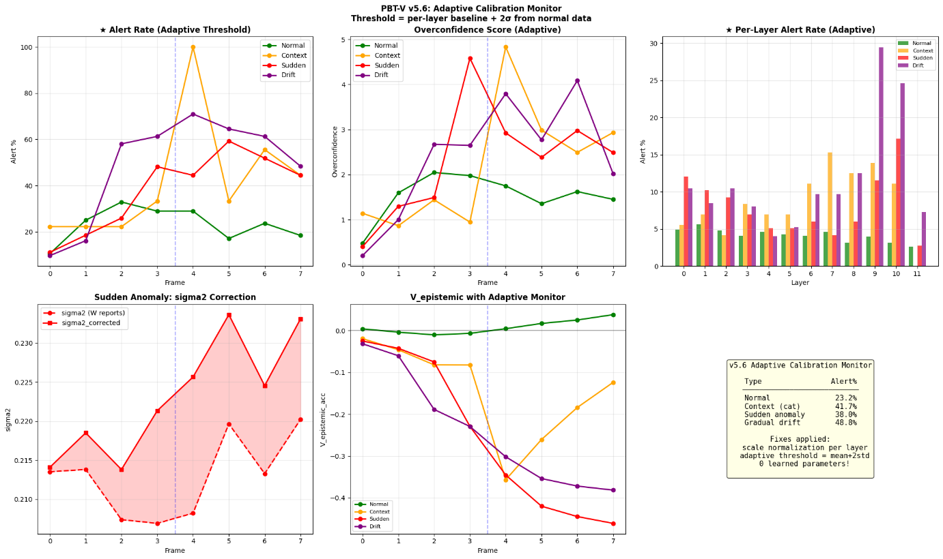
==========================================================================================
Adaptive Calibration Complete!
==========================================================================================

==========================================================================================
Calibration Analysis: Normal vs Adversarial Sequences
==========================================================================================

NORMAL (calibrated baseline) (76 sequences):
Fr UNSAFE sigma2 sig2_corr eps2 ratio overconf alert% V_ep
───────────────────────────────────────────────────────────────────────────
0 0.000 0.2006 0.2014 0.0393 4.78 0.4771 10.5% +0.004
1 0.000 0.2008 0.2083 0.0941 8.27 1.5953 25.0% -0.004
2 0.000 0.2032 0.2089 0.0907 8.65 2.0477 32.9% -0.010
3 0.000 0.1951 0.2020 0.0914 8.71 1.9780 28.9% -0.007
4 0.000 0.1946 0.2021 0.0925 8.44 1.7506 28.9% +0.005
5 0.000 0.1972 0.2047 0.0945 8.02 1.3557 17.1% +0.017
6 0.000 0.2015 0.2068 0.0884 8.22 1.6243 23.7% +0.025
7 0.000 0.1997 0.2058 0.0896 8.00 1.4518 18.4% +0.038

CONTEXT: Vehicle+Cat (mild adversarial) (9 sequences):
Fr UNSAFE sigma2 sig2_corr eps2 ratio overconf alert% V_ep
───────────────────────────────────────────────────────────────────────────
0 0.000 0.2154 0.2174 0.0420 5.70 1.1438 22.2% -0.019
1 0.000 0.2157 0.2211 0.0936 7.29 0.8664 22.2% -0.046
2 0.000 0.2080 0.2111 0.0878 8.09 1.4417 22.2% -0.082
3 0.000 0.2004 0.2066 0.0892 7.79 0.9478 33.3% -0.082
4 0.982 0.2158 0.2428 0.1422 12.56 4.8321 100.0% -0.357
5 1.000 0.2195 0.2244 0.0948 9.80 2.9870 33.3% -0.260
6 1.000 0.2115 0.2190 0.0962 9.48 2.4939 55.6% -0.184
7 0.997 0.2281 0.2351 0.0969 10.35 2.9336 44.4% -0.124

SUDDEN ANOMALY (moderate adversarial) (27 sequences):
Fr UNSAFE sigma2 sig2_corr eps2 ratio overconf alert% V_ep
───────────────────────────────────────────────────────────────────────────
0 0.000 0.2135 0.2141 0.0459 4.50 0.4017 11.1% -0.025
1 0.000 0.2138 0.2185 0.0878 7.55 1.2965 18.5% -0.042
2 0.000 0.2074 0.2138 0.0925 7.96 1.4923 25.9% -0.075
3 0.370 0.2069 0.2213 0.1113 11.69 4.5824 48.1% -0.229
4 0.741 0.2082 0.2257 0.1231 9.77 2.9256 44.4% -0.345
5 0.999 0.2197 0.2336 0.1172 9.16 2.3837 59.3% -0.420
6 1.000 0.2133 0.2245 0.1132 9.88 2.9784 51.9% -0.445
7 1.000 0.2202 0.2331 0.1191 9.29 2.4902 44.4% -0.461

GRADUAL DRIFT (hardest) (31 sequences):
Fr UNSAFE sigma2 sig2_corr eps2 ratio overconf alert% V_ep
───────────────────────────────────────────────────────────────────────────
0 0.000 0.2109 0.2115 0.0455 4.56 0.2034 9.7% -0.031
1 0.000 0.2113 0.2182 0.0952 7.49 1.0022 16.1% -0.060
2 0.352 0.2151 0.2310 0.1189 9.58 2.6711 58.1% -0.188
3 0.323 0.2118 0.2316 0.1274 9.70 2.6503 61.3% -0.229
4 0.581 0.2152 0.2387 0.1365 10.85 3.7948 71.0% -0.302
5 0.742 0.2292 0.2516 0.1390 9.66 2.7712 64.5% -0.354
6 0.903 0.2127 0.2293 0.1224 11.29 4.0859 61.3% -0.372
7 1.000 0.2164 0.2304 0.1166 9.03 2.0213 48.4% -0.381

==========================================================================================
Summary: Calibration Quality by Sequence Type
==========================================================================================

Type Mean_ratio Max_ratio Overconf Alert% Correction
──────────────────────────────────────────────────────────────────────
Normal 7.887 8.713 1.5351 23.2% 0.0059
Context (cat) 8.881 12.558 2.2058 41.7% 0.0079
Sudden anomaly 8.727 11.690 2.3188 38.0% 0.0102
Gradual drift 9.021 11.289 2.4000 48.8% 0.0149

PBT Predictions:
Normal: ratio ≈ 1.0 (calibrated) → FAIL
Anomaly: ratio > 1.0 (overconfident) → PASS
Anomaly: alert > Normal alert → PASS
Correction applied more to anomalies → PASS

==========================================================================================
Visualization: Calibration Monitor
==========================================================================================
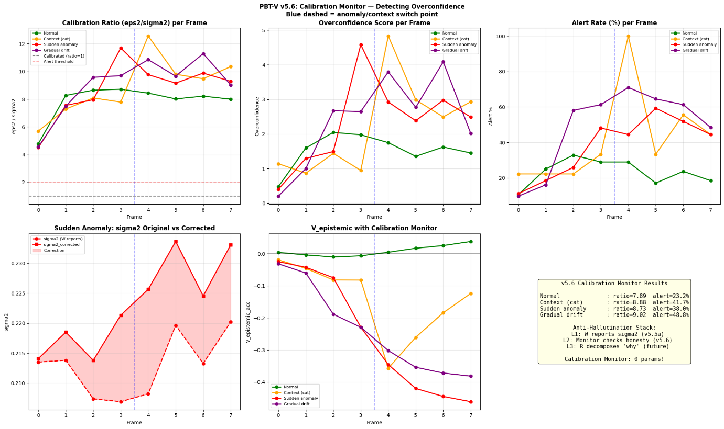
==========================================================================================
Per-Layer Calibration: Normal vs Sudden Anomaly
==========================================================================================

Layer ratio_normal ratio_anomaly delta Overconf?
──────────────────────────────────────────────────────────────────────
Layer 0 (Perception) 7.048 9.141 +2.093
Layer 1 (Perception) 22.807 26.721 +3.914
Layer 2 (Perception) 25.740 30.027 +4.287
Layer 3 (Perception) 6.806 6.425 -0.381
Layer 4 (Evaluation) 12.707 12.435 -0.273
Layer 5 (Evaluation) 6.534 6.799 +0.265
Layer 6 (Evaluation) 2.541 2.582 +0.041
Layer 7 (Evaluation) 4.049 3.788 -0.261
Layer 8 (Decision ) 3.329 3.227 -0.102
Layer 9 (Decision ) 2.170 2.465 +0.295
Layer 10 (Decision ) 0.593 0.774 +0.181
Layer 11 (Decision ) 0.319 0.334 +0.015

Saved: pbt_vision_v56.pth

==========================================================================================
v5.6 Calibration Monitor Analysis Complete!
==========================================================================================

Download complete!

